

Rich Web Applications Assignment 2

Nicholas Randles – B00058026

Dereck O’Brien –B00003398

BS in Computing in Information Technology BN302

**Table of contents**

Abstract……………………………………………………………………………………………………………………………..…1

Design of application…………………………………………………………………………………………………….……..1

Introduction………………………………………………………………………………………………………………………….1

Wire framing………………………………………………………………………………………………………………………..2

Working Application………………………………….………………………………………………………………………….5

* Home page………………………..……………………………………………………………………………………..7
* Activities page……………….………………………………………………………………………………………….8
* Videos page………………………………………………………………………………………………………………9
* Photos page…….………………………………………………………………………………………………………11
* Videos page………………………..…………………………………………………………………………………..13
* Contact page……………………………………..……………………………………………………………………14

How did what….………………………………………………………………………………………………………………….18

What we learned……………….……………………………………………………………………………………………….19

**Abstract**

This document contains the steps involved in creating a mobile application for a community centre. The document focuses in on the planning and construction of the mobile website for Ratoath Community Centre. The document shows all of the features that where implemented into the mobile app and the specific reason they were implemented. It shows who implemented what features in the project. It also shows what we learned from doing the project.

**Design of Application**

**Introduction**

We decided to use Nicky’s desktop website and make a mobile version for it. We used jQuery mobile to achieve this. We took the activities page from his site and we created a page called Activities. We added the activities to wordpress and we read them in to the app using the JSON API plugin. We then created another page called show activity. This page would show the user information about the activity they selected. We used the map from Nicky’s locate us page, except we had to make some adjustments and improvements to make it suitable for mobile. We took information from Nicky’s contact us page. We used a collapsible set to make this information more mobile friendly. We recreated Nicky’s about us page. We had to make the pictures smaller and put in less text so that that it was more suitable for mobile.

**Wire Framing**

This is a rough idea for the Home page of the mobile website.

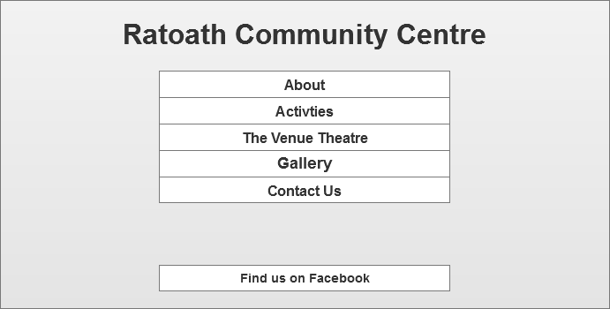

This is a rough idea for the About Us page of the mobile website.

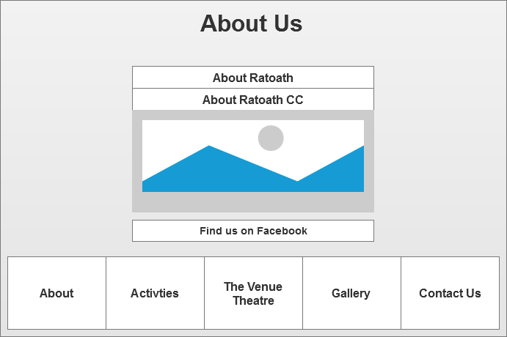

This is a rough idea for the Gallery page of the mobile website.

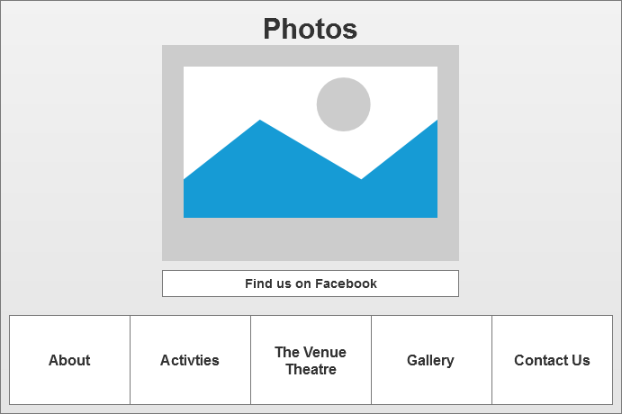

This is a rough idea for the Contact Us page of the website.

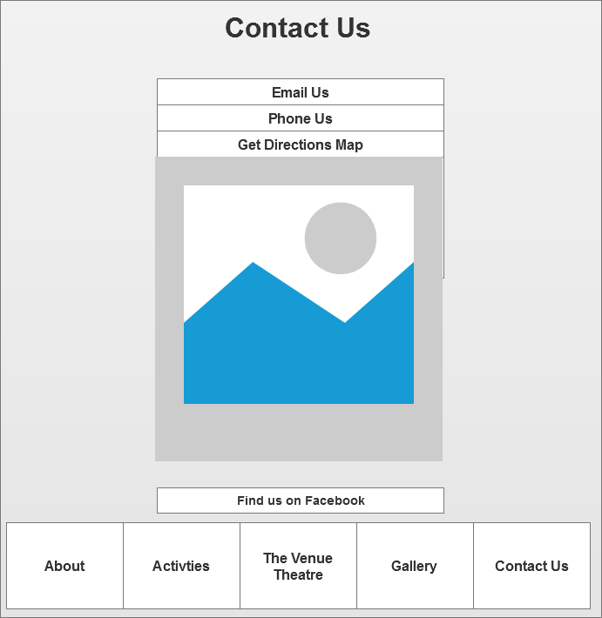

This is a rough idea for the Activities page of the web site.

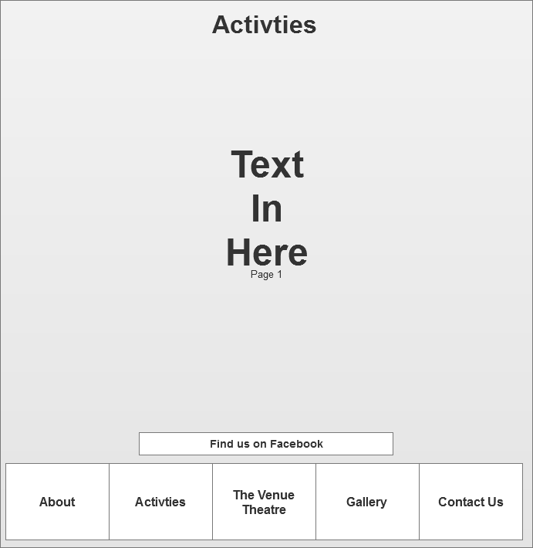

**Working application**

We used a script that detects if the user is on a mobile device. If the user is on a mobile device they will be redirected to <http://dereckandnicky.com/mobile>. If they are not they will stay at <http://dereckandnicky.com/>.

Desktop version - http://dereckandnicky.com

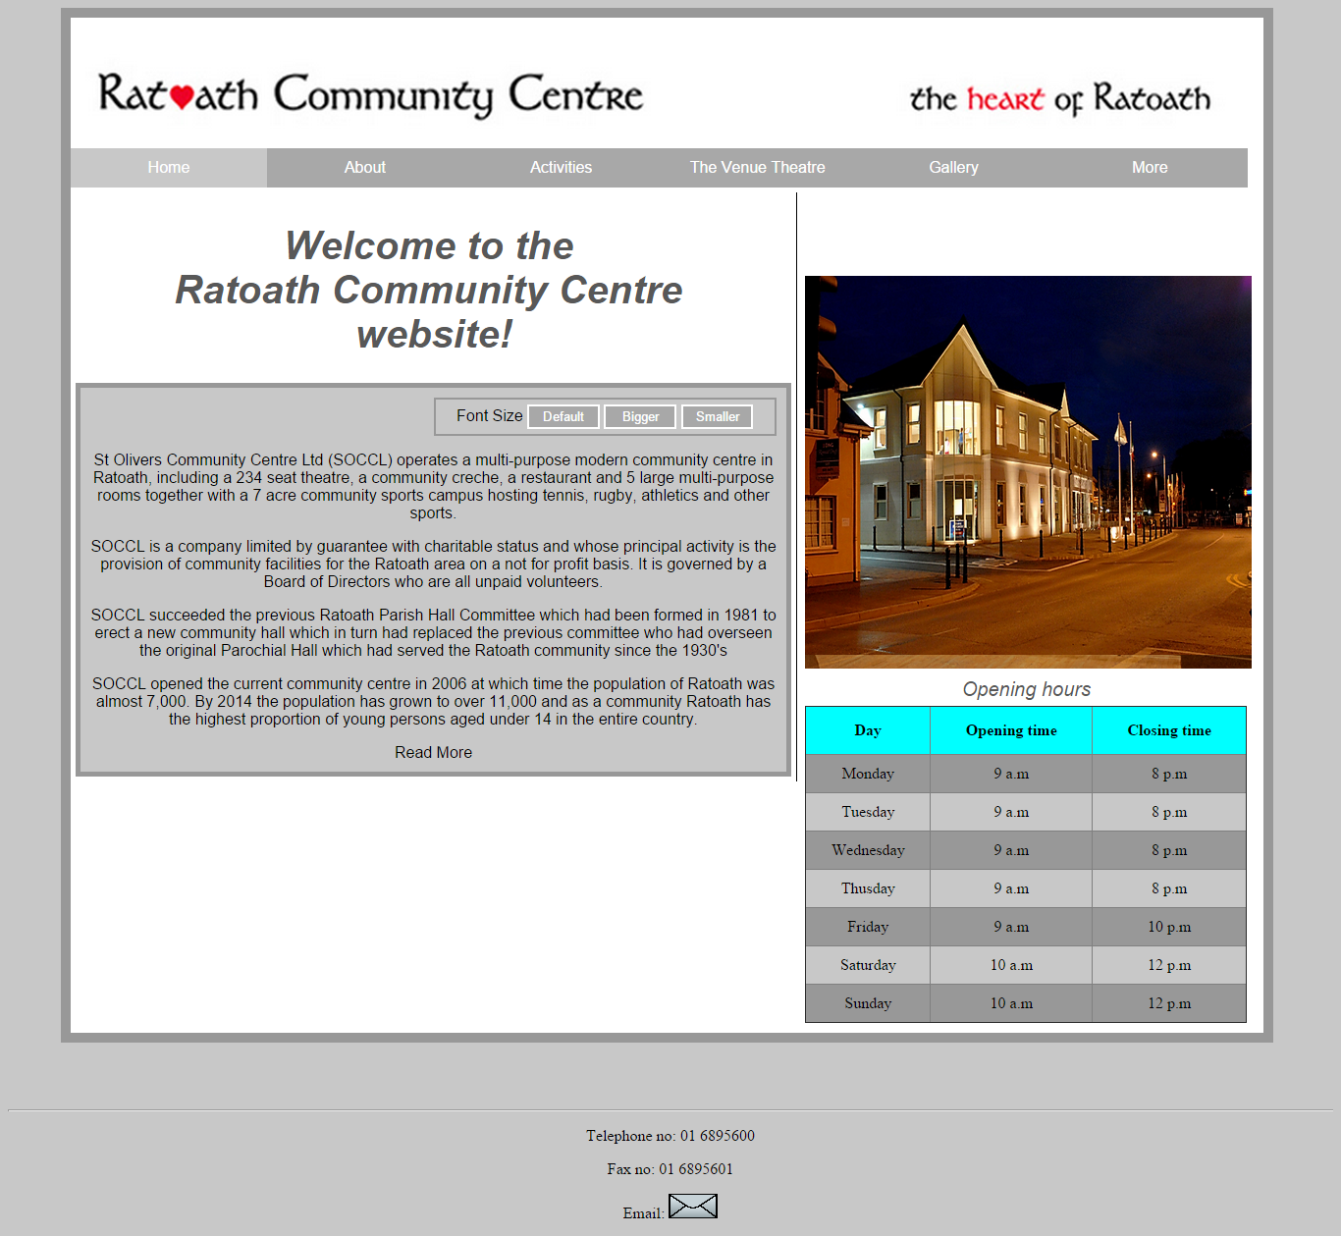

Mobile version – http://dereckandnicky.com/mobile

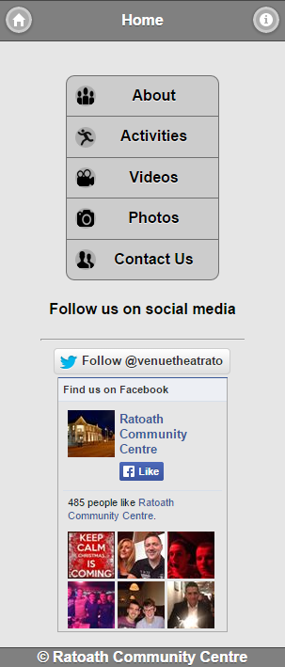

**Home page**

This page contains a control group with all links to all of the other pages. When a link is pressed the user is taken to one of the other pages. Below the control group there are social media options which the user can select. They can choose to follow the Ratoath Community Centre on Twitter or like their Facebook page

**Information page**

When the user selects the information icon in the header, a dialog box will pop up showing them information about the app.

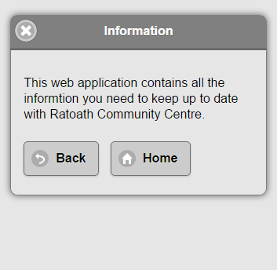

**About page**

When the user goes on to this page they will see a collapsible set. One of the collapsibles contains information about Ratoath and the other contains information about Ratoath Community Centre. The collapsibles also contain an image. When the user presses one of the images, the image will be displayed larger in a dialog box.

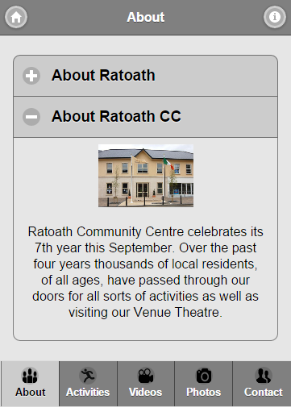

**Image selected on about page**

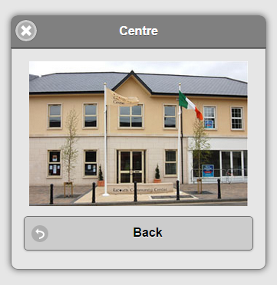

**Activities page**

This page contains all of the activities that have been posted in wordpress. They are read into the activities page via the JSON API plugin. When the user selects an activity they will be taken to another page called activityPost. This page contains more information about the activity they selected and also gives them the option to like it via the Facebook like button plugin or share it on Twitter via the Twitter share button plugin.

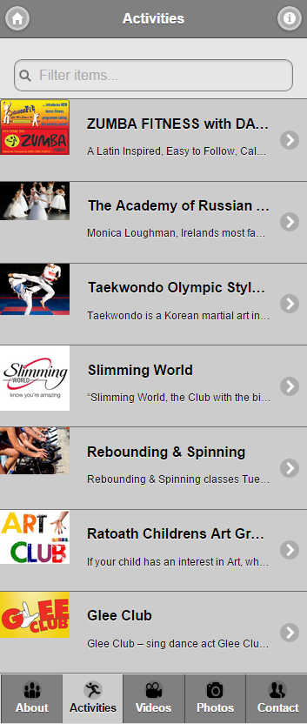

**When activity is selected**

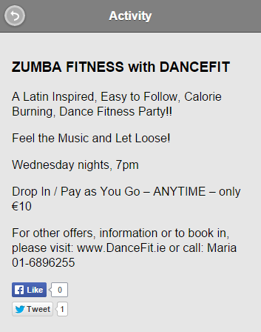

**Video page**

This page contains a list of videos from the Ratoath Community Centre YouTube page. They have been imported via the YouTube API. They are displayed in a ui-grid-c layout. The user can press one of the videos and they will be taken to the showVideo page. This page plays the video. It also shows the title and description of the video.

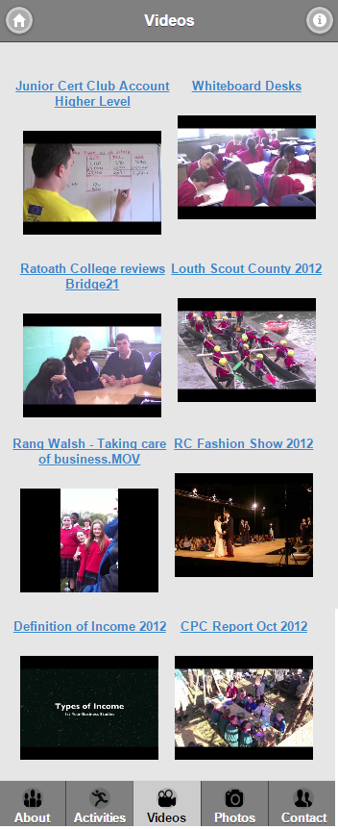

**When video is selected**

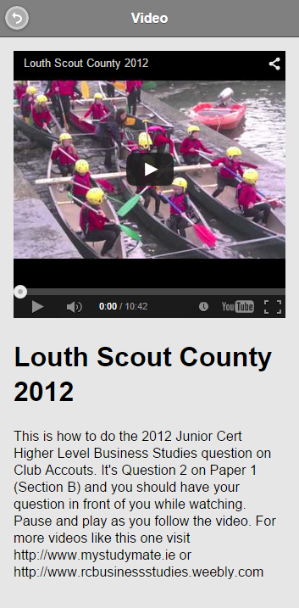

**Photos page**

This page contains pictures of Ratoath Community Centre. They are from a Flickr account we set up. They have been imported using the Flickr API. They are display with a ui-grid-c layout. When the user selects an image they will be taken to another page called showPhoto. This page displays the image much large for the user.

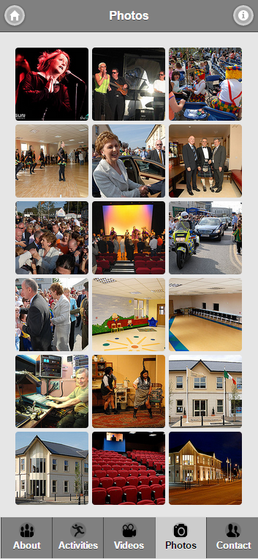

**When photo is selected**

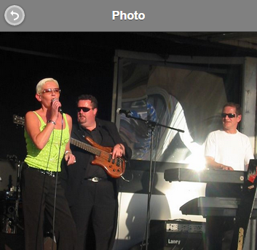

**Contact us page**

This page contains a collapsible set. In the collapsible set there are collapsibles called location, phone and email. The location collapsible contains a Google map and a nested collapsible set which shows the directions. When the user enters in their current location they can then click on the directions collapsible to see the directions. The phone collapsible contains a nested collapsible set with two collapsibles. One contains the phone number for the centre and the other contains the fax number for the centre. The email collapsible contains an email form. The user can enter in their details, type a comment and rate the app. Once they have done this they can press send. Their message will then be send to the Ratoath Community Centre email address.

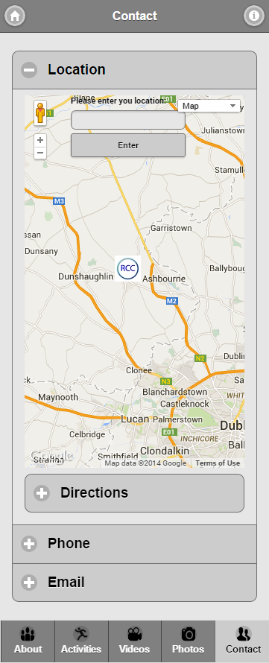

**Contact page with user’s location entered.**

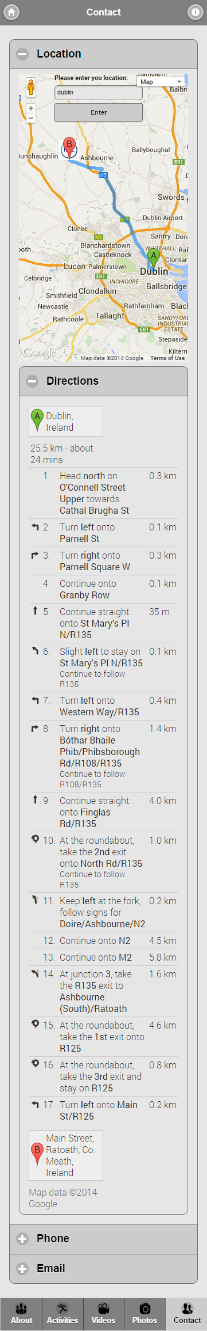

**Contact page with email form displayed**

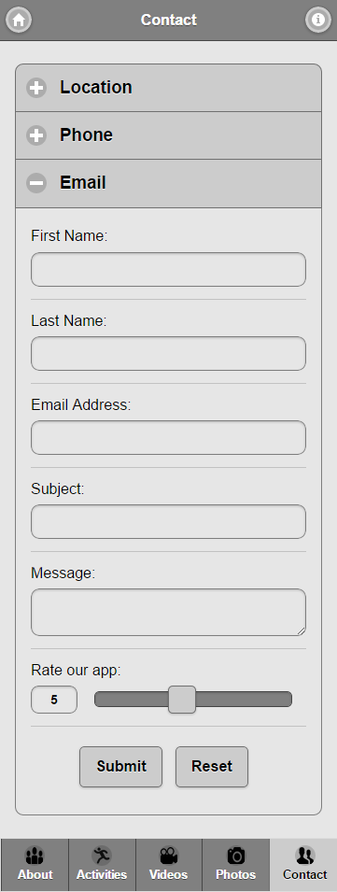

**Who did what?**

We both found this project difficult but by working together and using our combined knowledge of web applications we were able to get it done. Nicky installed wordpress and the JSON API plugin. He then used the JSON API to import the recent posts from the wordpress page. He then added them to the activities page and made it possible for the user to select each activity and learn more about them. Dereck implemented the Flickr API. He set up a Flickr account and uploaded photos to it. He then used the API to import the files to the photos page. He then made it possible for the user to select the images and view it larger on another page. The YouTube API was quite difficult to implement but by working together we were both able to do it. For the contact page, Nicky worked on the Google maps and Dereck worked on the contact form. For the social media plugins, Nicky worked on the Facebook plugins and Dereck worked on the twitter plugins.

**What we learned from the project.**

We both learned a lot from doing this assignment. We got to learn about all of the great features jQuery provides. We learn how to make dynamic pages by using apis. We learned a lot about wordpress, we learned how you can publish posts and feed them through your app via the JSON api plugin. We also got to learn a lot about the flickr and youtube apis. We learned how you can use them to make dynamic video and photo pages. We also learned a lot about google maps api and how you can make your own custom map to suite your own needs. We also learned about device detection. We found out how to detect whether the user is on a mobile browser or a desktop browser with JavaScript.We also got to learn about the social media plugins that Facebook and twitter both provide.

References

1. *Ratoath community centre - the heart of ratoath, county meath*Retrieved 12/6/2014, 2014, from <http://ratoathcc.ie/index.php>
2. *Jquery*Retrieved 12/6/2014, 2014, from <http://jquery.com/>
3. *jQuery mobile* Retrieved 12/6/2014, 2014, from <http://jquerymobile.com/>
4. *ThemeRoller | jQuery mobile* Retrieved 12/6/2014, 2014, from <http://themeroller.jquerymobile.com/>
5. *Icons - jQuery mobile demos* Retrieved 12/6/2014, 2014, from <http://demos.jquerymobile.com/1.4.2/icons/>
6. *Twitter buttons | About* Retrieved 12/6/2014, 2014, from <https://about.twitter.com/resources/buttons>
7. *Social plugins* Retrieved 12/6/2014, 2014, from <https://developers.facebook.com/docs/plugins?locale=en_GB>
8. *Flickr Services* Retrieved 12/6/2014, 2014, from <https://www.flickr.com/services/api/>
9. *Wordpress> Blog Tool, Publishing Platform, and CMS* Retrieved 12/6/2014, 2014, from <https://wordpress.org/>
10. *Getting Started - Google Maps JavaScript API v3* Retrieved 12/6/2014, 2014, from <https://developers.google.com/maps/documentation/javascript/tutorial>
11. *YouTube for Developers – YouTube* Retrieved 12/6/2014, 2014, from <https://www.youtube.com/yt/dev/>
12. *Detect mobile browsers - open source mobile phone detection* Retrieved 12/7/2014, 2014, from <http://detectmobilebrowsers.com/>